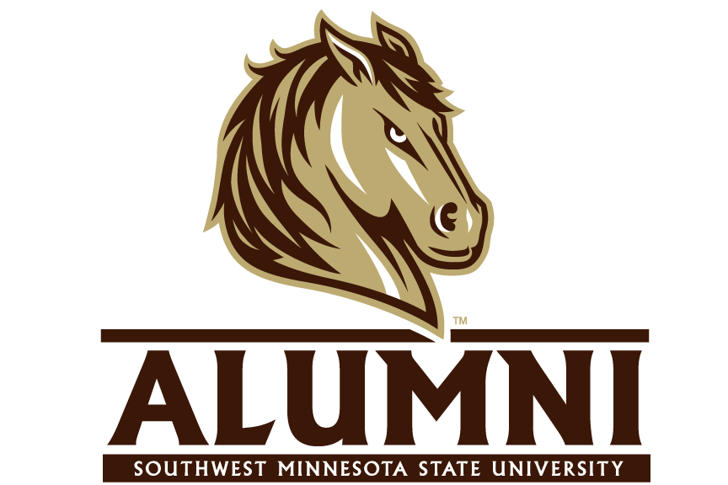
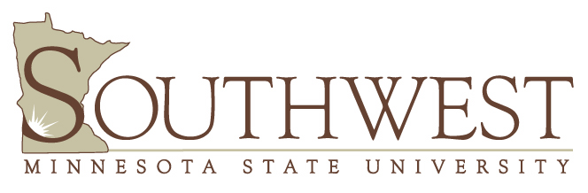

TYPE OF POSITION: Graduate Assistantship, Advancement (Alumni Relations)
SALARY: $10,000 plus tuition waiver (full-year)

OVERVIEW:
Assist in the development and implementation of programs, services and events within the Alumni Office at Southwest Minnesota State University.

QUALIFICATIONS:
- Must be admitted and enrolled into a master’s program at Southwest Minnesota State University
- Must maintain a GPA of 3.0 or above throughout the time of employment
- Must have demonstrated excellent interpersonal and organizational skills
- Must have the ability to work independently as well as the ability to work with volunteers
- Experience in desktop publishing, graphic design and web publishing preferred
- Must be willing and able to work evenings and weekends
- Motivated individual with a positive attitude and strong work ethic

RESPONSIBLITIES:
- Assist with marketing/promotions and facilitation of alumni events and programs
- Develop marketing strategies to engage young alumni and current students
- Design marketing concepts such as flyers, ads, display cases, posters, signs, brochures and other projects
- Develop text for print and web publication
- Develop communications strategies and materials for a variety of audiences
- Develop collaborative opportunities and programs with other departments
- Compile statistical information on marketing initiatives and report as necessary
- Conduct evaluations and benchmarking on current alumni events and programs
- Involvement in young and student alumni programs, mentoring and recruitment initiatives
- Assist with events within the Advancement team as well as support for the GOLD College program
- Manage and execute social media strategies
CLIENTELE:
Current SMSU alumni including alumni degree holders, alumni master degree only, and alumni non-degree holders.
APPLICATION INFORMATION:
Include cover letter, resume, unofficial transcript and the names and phone numbers of two (2) references.

APPLY TO:
Angela Lee – Director of Alumni Relations & Outreach
Alumni Association, Southwest Minnesota State University
1501 State Street, Marshall, MN 56258
Inquiries about the position may be directed to the Director of Alumni Relations at Angela.Lee@smsu.edu or
(507) 537-6646.

UNIVERSITY/COMMUNITY:
Southwest Minnesota State University is one of seven universities in the Minnesota State Colleges and Universities system. SMSU gives highest priority to excellence in teaching and preparing students to be lifelong learners through quality undergraduate teaching/advising and close student/faculty relationships. The University has received the number one rank in its category from U.S. News & World Report for nine consecutive years. Its mission, dating back to 1967, provides access to university-level programs in liberal arts & professional studies. The University has a special commitment to the educational needs of the people in its service region reflected through its curricula, cultural programs, diversity of staff and students, cooperative relationships with the public and private sectors, and regional institutions. The 216-acre campus encompasses 24 modern, interconnected, and accessible buildings. Marshall (pop. 13,000) is the hub of a rich agricultural area and offers a variety of cultural, recreational and educational opportunities. Southwest Minnesota State University is an Equal Opportunity, Affirmative Action Employer.

